TheBookDesigner.com
Garry Rodgers submitted No Witnesses To Nothing designed by Derek Murphy CreativeIndie Covers. “Hi Joel, Please consider this cover. It made #5 on the Amazon BestSeller KDPS free promotion in the Horror category and 68 in Thriller. A bit of name dropping – Joanna Penn gave a testimonial for the back jacket. Thanks, Garry Rodgers Vancouver, Canada”
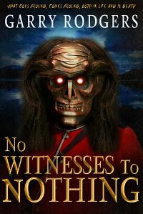
JF: Despite your powerful name-dropping, this is drop-dead terrific. Derek Murphy really hits it out of the park, not least because of this fantastic illustration.

